Google form link: 🡪 Upload and check your score in the leaderboard
https://docs.google.com/forms/d/e/1FAIpQLSeQ0ZcBLRuCax_O6rxp_h8IzO6oH34_7P4gSTAtNK9lcPogJg/viewform

Leaderboard:
https://docs.google.com/spreadsheets/d/1u6-qTg-i8q84W3iiipWkvlocgn4FqJIoMGqKPUrQnq8/edit?pli=1&gid=0#gid=0

Important emails:
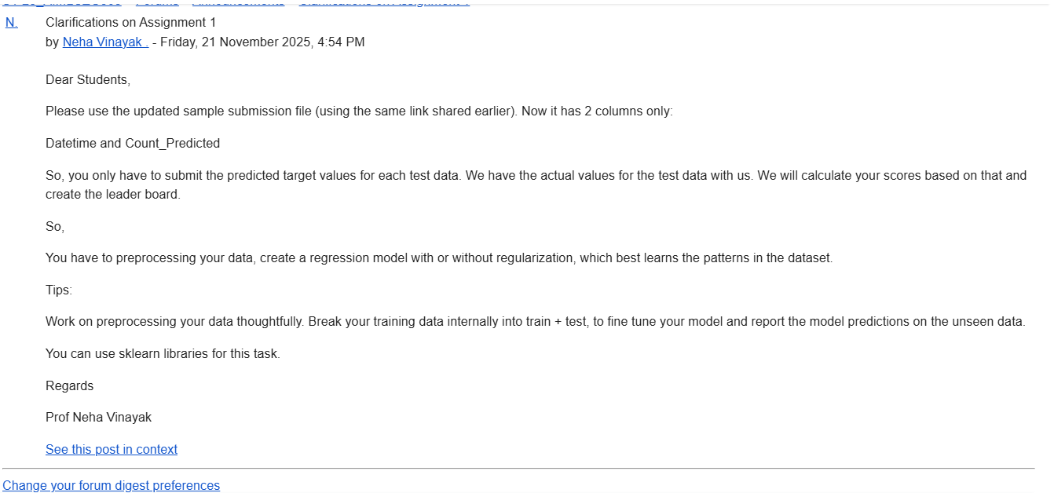
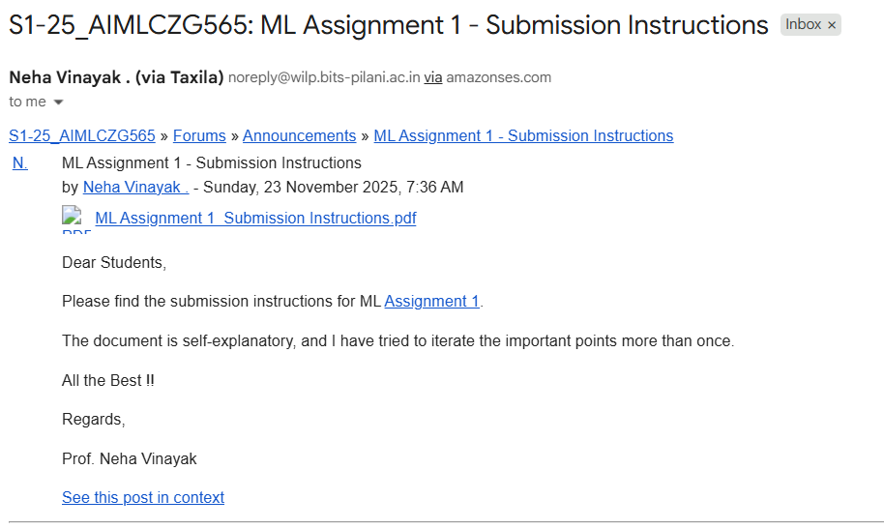
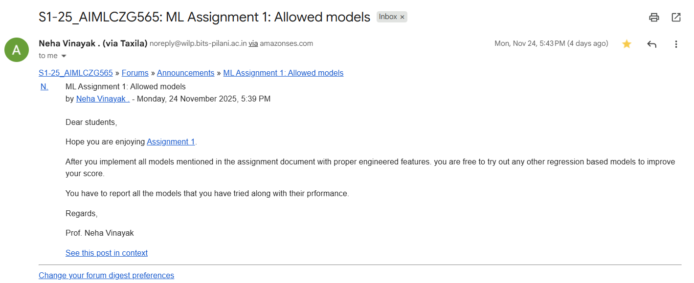

Few random & useful WhatsApp chats
Not the direct steps for preprocessing but set of prompts to get there👍. with simmilar prompts, I got values less than 0.5 : 1️⃣ Ask for Initial EDA & Understanding

“Here is my dataset [column headings]
Help me analyze the columns, identify feature types (numerical, categorical, cyclic, binary), and suggest what preprocessing is needed for each.”

2️⃣ Ask for Data Cleaning Guidance

“What data cleaning steps should I apply for this dataset?
Consider missing values, incorrect values, skewness, outliers, and type conversions.”

3️⃣ Ask for Feature Engineering Plan

“Tell me exactly how to engineer features for this dataset:
– which features to scale
– which to one-hot encode
– which need cyclical encoding
– which features to drop
– which transformations help linear/polynomial models.”

4️⃣ Ask for Cyclical Encoding Explanation

“Explain why hour, month, and dayofweek should be cyclically encoded, and show me the exact formula and code to apply it.”

5️⃣ Ask for Handling Multicollinearity

“Help me calculate VIF for my dataset, interpret the results, and suggest which features to drop or keep.”

6️⃣ Ask About Outlier Handling

“Which features should I check for outliers, how do I detect them, and what is the safest way to treat them for regression models?”

7️⃣ Ask for Target Transformation Strategy

“Should I log-transform the target column (‘count’)? Explain why, how, and what impact it has on model performance.”

8️⃣ Ask for Base Linear Regression

“Give me the correct training & evaluation code for a simple Linear Regression model with all preprocessing applied. Include R², RMSE, MAE, RMSLE.”

9️⃣ Ask for Polynomial Regression

“Now add PolynomialFeatures (degree=2 and degree=3).
Explain why polynomial helps, fit the model, and evaluate performance.”

1️⃣0️⃣ Ask for Regularization

“Apply Ridge and Lasso regression on polynomial features.
Tune alpha values across multiple magnitudes and show which α gives the best R², RMSE, and RMSLE.”

1️⃣1️⃣ Ask for Model Comparison
copy paste your results and
“Summarize the performance of Linear, Polynomial, Ridge, and Lasso models in a table.
Explain which one is best and why.”

Few pointers. Do note that I have not yet submitted. Still exploring and understanding.

1. Can check for R2 score (model fit not error) to ensure you are not overfitting while training. For linear models even R2 score of . 7 is very good. 1 means perfect fit but will definitely lead to overfitting.
2. Feature engineering and selection and one hot encoding for categorical features . Hour and year have very strong correlation. Apart from that check for others.
3. Use log count initially instead of count (read on this still understanding this in detail but count numbers will be more normally distributed on using log count). Later reconvert to actual scale before checking RMSLE and submission
4. Use standard scaler on train data
5. After doing all this correctly the linear model should give good score of RMSLE around. 7 to. 8. Hoping this is not an overfitted model
6. Then use polynomial regression degree 2 should be enough and some marked improvement should be visible in RMSLE.
7. Apply ridge and lasso - would led to some very minor improvement if any
8. Submit and enjoy your journey to top of the leaderboard

Don't fret too much on leaderboard score. If you have made successful submission and answered other questions, you will get more than average marks.

Read on kaggle implementation of other people for this dataset to enhance your learning and understanding to figure out in case your RMSLE score is very high. I think for anyone trying himself and not copying anything under 1.5 is a good score.

In case you want some number plain vanilla linear regression should achieve. 7 and with improvements under. 5

i saw some one extended the features to 40+, i felt like this needs more features since there are 10K+ rows so i also did extend the feature more than 40 and trained the model ,
Polinomial degreee 2 with 40+ feature should result in less RMSLE value

You need remove negative values from predictions. There is a method to put maximum value as 0 for negative values. I applied then leaderboard showing okay for me. Not sure whether it is right approach or not

We need to split bike_train into train and validation. We train and validate the model on this data.

We test the data using bike_test. You will have to submit the prediction (count) against the datetime in submission.csv

Few points to note:

1. When training the model with train csv file, you are doing split (80/20). Hence, once the training is completed, the model is 80% trained

2. You have to train the model in Linear Regression, apply polynomial tranformations, train in Lasso and Ridge regression and then gather the RMSLE value. Choose the best out of three regression models based on their lowest RMSLE value

3. Once you choose the model from point 3, you have to train your model with fill train csv file. Why? Because the model was trained on 80% train data during the split. Hence, to predict the new values, you need to train your best model on the complete train csv file and THEN predict the values from test csv file, save the predicted values in the submission csv file

